Data Science Unit 2: GUI, Internet Programming and Python Tools

Unit overview
Part | Syllabus topics | What you can build with it
1. GUI Programming | Python GUI options, adding widgets, GUI coding techniques, customizing widgets | A desktop window with buttons, text boxes and menus
2. Internet Programming | Network scripting, client-side scripting, PyMailGUI client, server-side scripting, PyMailCGI server | Programs that fetch pages, send mail or serve web pages
3. Tools and Techniques | Databases and persistence, data structures, text and language, Python/C integration | Saved data, efficient structures, text parsers and fast C-backed code
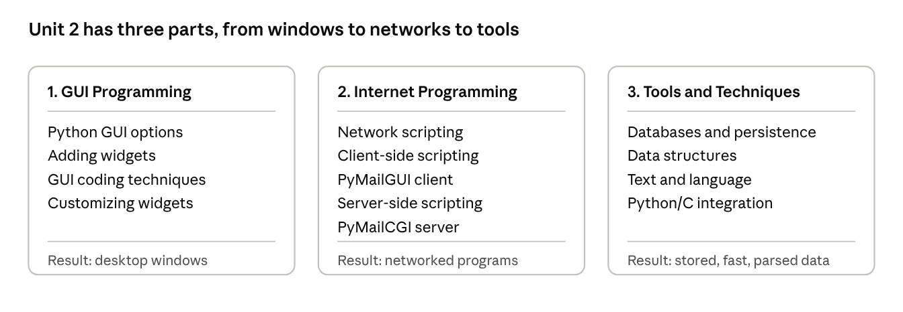
unit roadmap · 3 parts
PyMailGUI and PyMailCGI are case-study programs from Mark Lutz's Programming Python, a prescribed text book. This guide explains the ideas and Python tools those programs demonstrate; read the book's matching chapters for their full source.

1. GUI Programming
A graphical user interface (GUI) lets people use a program through windows, buttons and text boxes instead of typing commands; in Python the standard toolkit for this is Tkinter, and every GUI program works as an event loop that reacts to user actions.

1.1 Python GUI development options
Python has several GUI toolkits. Choose by licence, platform, look and how much you want to install.
Toolkit | Comes with Python? | Notes
Tkinter (with ttk) | Yes, in the standard library | Simple, portable and ideal for learning and small tools
PyQt / PySide | No (pip install) | Powerful Qt toolkit for large, polished desktop applications
wxPython | No | Uses the native widgets of each operating system
Kivy | No | Touch-friendly, runs on desktop and mobile
Web-based GUI (Flask, Streamlit, Dash) | No | The user interface runs in a browser instead of a desktop window
This unit uses Tkinter because it needs no installation, and its concepts (widgets, layout, events, callbacks) carry over to every other toolkit.

1.2 Adding widgets
A Tkinter program has three steps: create a root window, create widgets inside it and place them with a geometry manager, then start the event loop with mainloop().
import tkinter as tk
root = tk.Tk()
root.title("Greeter")
label = tk.Label(root, text="Enter your name:")
entry = tk.Entry(root, width=20)
result = tk.Label(root, text="")
def greet(): # callback function
result.config(text="Hello, " + entry.get())
button = tk.Button(root, text="Greet", command=greet)
label.pack()
entry.pack()
button.pack()
result.pack()
root.mainloop() # wait for events until the window closes
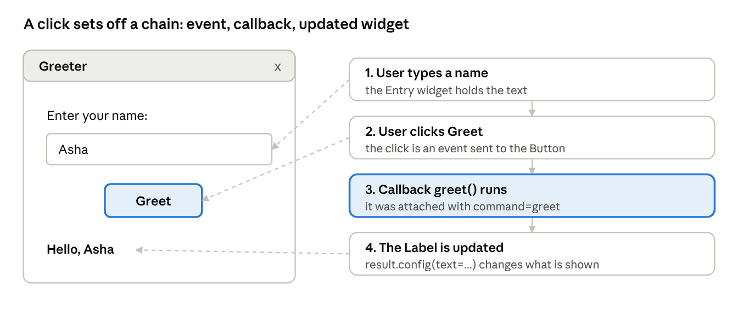
Tkinter window and its event chain · 4 steps
The window on the left is what the program above draws; the cards on the right show what happens when the button is clicked.
Widget | Purpose
Label | Shows text or an image
Button | Runs a callback when clicked
Entry | One-line text input
Text | Multi-line text area
Frame | Container used to group widgets
Checkbutton / Radiobutton | Tick box / one-of-many choice
Listbox | List of selectable items
Scale / Spinbox | Slider / number selector
Canvas | Area for drawing shapes, lines and images
Menu | Menu bar and pop-up menus
Toplevel | An extra window
Standard dialogs are ready-made: tkinter.messagebox (alerts and confirmations), tkinter.filedialog (open and save pickers) and tkinter.colorchooser.
Geometry managers decide where each widget sits. Use only one manager inside any one container.
Manager | Idea | Example
pack | Stack widgets against a side of the container | w.pack(side="left", fill="x", padx=5)
grid | Place in rows and columns of a table | w.grid(row=0, column=1, sticky="w")
place | Exact x and y position | w.place(x=20, y=40)
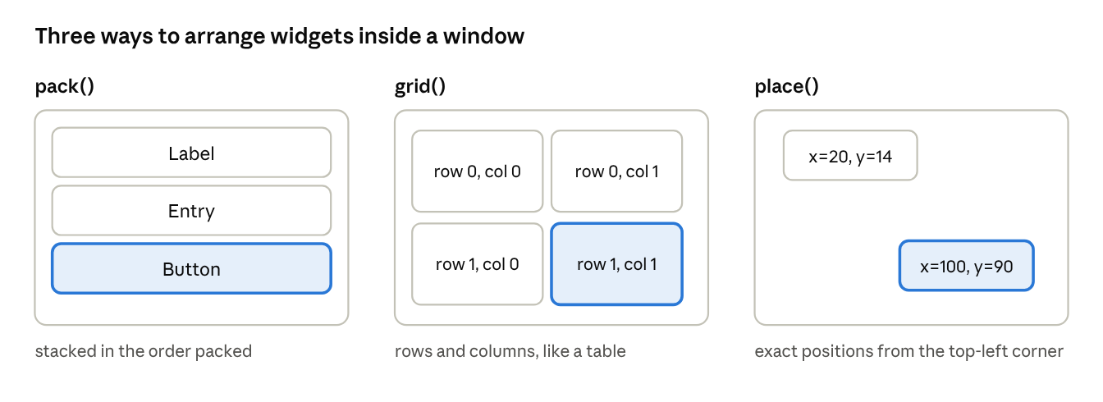
pack, grid and place layouts

1.3 GUI coding techniques
- Event loop and callbacks. mainloop() waits for events such as clicks and key presses. Your function (the callback) runs when its event happens, and must return quickly or the window freezes.
- Event binding. widget.bind("<Return>", handler) attaches a function to any event; the handler receives an event object with details such as the key or mouse position.
- Control variables. StringVar, IntVar and BooleanVar keep a widget and your program in sync: var = tk.StringVar(); tk.Entry(root, textvariable=var), then var.get() anywhere.
- Class-based design. Wrap a window in a class so state and callbacks live together.
- Timers. root.after(1000, func) schedules a call after 1000 ms without blocking.
- Long tasks. Never run a slow job (download, heavy calculation) inside a callback. Run it in a worker thread and pass results back through a queue.Queue, polling it with after(), because widgets must only be changed from the main thread.
- Callbacks with arguments. Use lambda: Button(root, text="Add", command=lambda: add(5)).
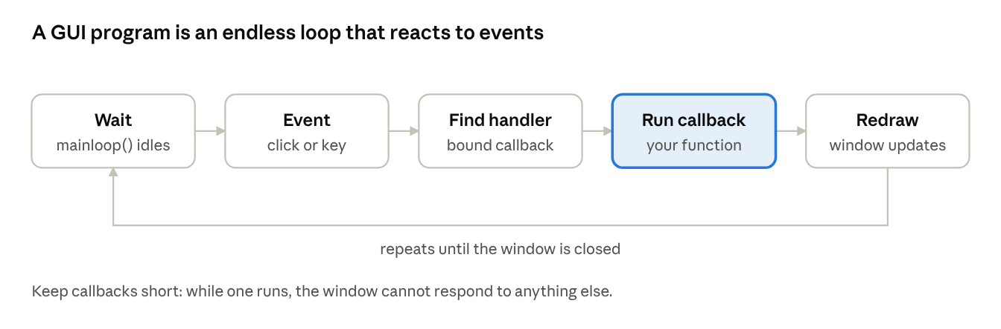
GUI event loop · 5 stages
import tkinter as tk
from tkinter import messagebox
class CounterApp(tk.Frame):
def __init__(self, master):
super().__init__(master)
self.count = tk.IntVar(value=0) # shared state
tk.Label(self, textvariable=self.count, font=("Arial", 24)).grid(row=0, column=0, columnspan=2)
tk.Button(self, text="+1", command=self.add).grid(row=1, column=0)
tk.Button(self, text="Reset", command=self.reset).grid(row=1, column=1)
master.bind("<Escape>", lambda e: master.destroy()) # key binding
self.pack(padx=20, pady=20)
def add(self):
self.count.set(self.count.get() + 1)
if self.count.get() == 10:
messagebox.showinfo("Counter", "You reached 10!")
def reset(self):
self.count.set(0)
root = tk.Tk()
CounterApp(root)
root.mainloop()

1.4 Customizing widgets
- Options. Most widgets accept font, fg (text colour), bg (background), width, height, relief (flat, raised, sunken, groove), cursor, state (normal or disabled) and padx / pady. Change them later with widget.config(option=value).
- Fonts and colours. font=("Helvetica", 14, "bold"); colours are names ("navy") or hex codes ("#2a7ae2").
- Images. img = tk.PhotoImage(file="logo.png") then Label(root, image=img); keep a reference to img or it disappears.
- Themed widgets (ttk). from tkinter import ttk gives modern-looking ttk.Button, ttk.Entry, ttk.Combobox, ttk.Treeview and ttk.Notebook (tabs); style them with ttk.Style().
- Custom widgets. Subclass an existing widget to create a reusable component with its own defaults and behaviour.
- Menus. Build a menu bar with tk.Menu and add_command(label=..., command=...).
- Drawing. Canvas methods such as create_line, create_rectangle, create_oval and create_text let you draw charts and games.
import tkinter as tk
class HoverButton(tk.Button): # a customized widget
def __init__(self, master, **kw):
super().__init__(master, bg="#e8e8e8", relief="groove", font=("Arial", 12), **kw)
self.bind("<Enter>", lambda e: self.config(bg="#cfe3ff")) # mouse over
self.bind("<Leave>", lambda e: self.config(bg="#e8e8e8")) # mouse away
root = tk.Tk()
HoverButton(root, text="Hover over me", command=root.destroy).pack(padx=30, pady=30)
root.mainloop()

2. Internet Programming
Internet programs follow the client-server model: a server waits for requests on a network address and port, and a client connects, sends a request and reads the reply; Python's standard library covers every layer from raw sockets to email and web pages.

2.1 Network scripting
A socket is one end of a two-way network connection, identified by an IP address and a port number. Higher-level protocols such as HTTP (web), SMTP (send mail), POP3 and IMAP (read mail) and FTP (file transfer) are built on top of sockets.
Module | What it does
socket | Low-level TCP and UDP connections
socketserver | Framework for writing servers that handle many clients
urllib.request / http.client | Fetch web pages and call web services
smtplib | Send email through an SMTP server
poplib / imaplib | Read email from a mailbox
ftplib | Upload and download files by FTP
email | Build and parse email messages and attachments
json | Convert data to and from the text format used by web APIs
# server.py : a minimal TCP echo server
import socket
server = socket.socket(socket.AF_INET, socket.SOCK_STREAM) # TCP socket
server.bind(("127.0.0.1", 5000)) # claim address and port
server.listen() # start waiting for clients
print("Waiting for a client...")
conn, addr = server.accept() # blocks until a client connects
with conn:
data = conn.recv(1024) # read up to 1024 bytes
conn.sendall(b"Echo: " + data) # reply
server.close()

# client.py
import socket
with socket.socket(socket.AF_INET, socket.SOCK_STREAM) as s:
s.connect(("127.0.0.1", 5000)) # connect to the server
s.sendall(b"Hello server")
print(s.recv(1024).decode()) # Echo: Hello server
Sockets carry bytes, so text must be encoded ("text".encode()) before sending and decoded after receiving. Run the server first, then the client in a second terminal.
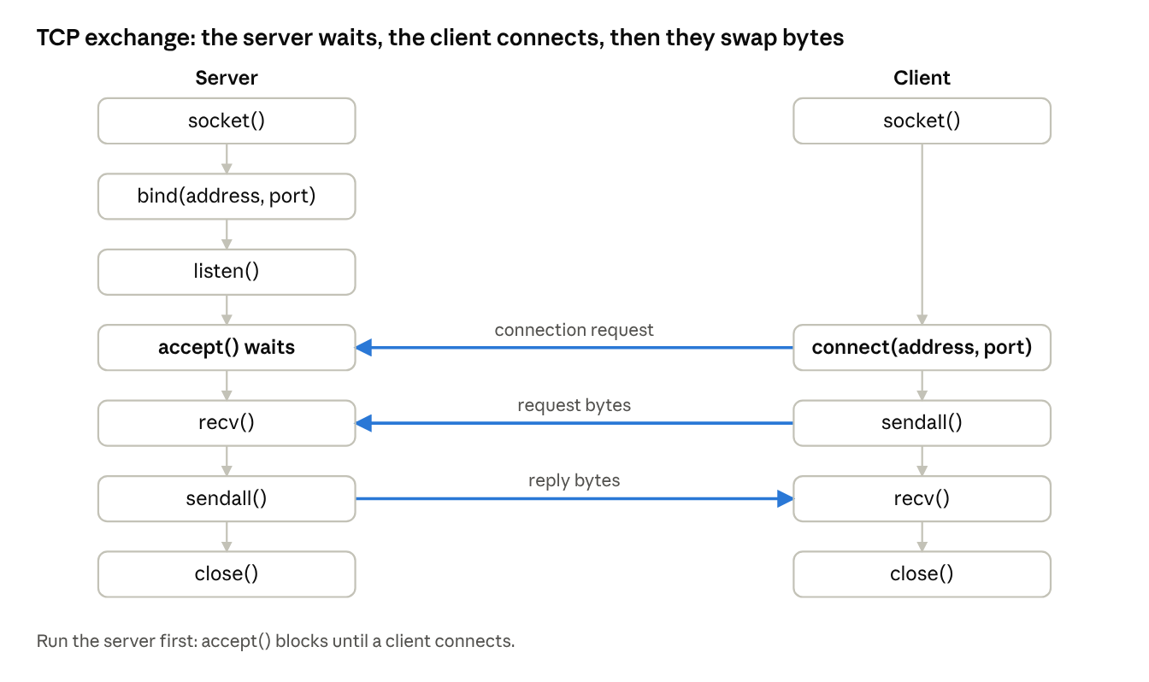
socket call sequence · server and client

2.2 Client-side scripting
A client-side script runs on the user's machine and acts as the client of some server: it opens connections, sends requests and processes replies. It does not wait for requests from others.
from urllib.request import urlopen
import json
with urlopen("https://example.com") as page: # HTTP GET request
html = page.read().decode("utf-8")
print(html[:80])
# sending an email with the standard library
import smtplib
from email.message import EmailMessage
msg = EmailMessage()
msg["From"] = "me@example.com"
msg["To"] = "friend@example.com"
msg["Subject"] = "Test"
msg.set_content("Hello from Python")
with smtplib.SMTP("smtp.example.com", 587) as smtp: # placeholder server
smtp.starttls()
smtp.login("me@example.com", "app-password")
smtp.send_message(msg)
Typical client-side jobs are downloading files, calling web APIs, checking mailboxes, and GUI programs that talk to a server. The third-party requests library is a popular friendlier alternative to urllib.

2.3 The PyMailGUI client
PyMailGUI is a full desktop email client written in Python with Tkinter, presented as a case study in Programming Python. It shows how the earlier ideas combine in one real program:
- GUI layer (Tkinter): windows for the mail list, reading, composing, replying and forwarding, with menus and buttons.
- Network layer: poplib (or IMAP) downloads messages and smtplib sends them.
- Message layer: the email package parses headers, bodies and attachments and builds new messages.
- Threads: slow network operations run in background threads so the window stays responsive, and a queue passes results back to the GUI.
- Persistence: local files keep loaded messages and settings.
It is a client-side program: all the code runs on the user's computer and the mail server only stores and delivers messages.

2.4 Server-side scripting
A server-side script runs on the server in answer to a request from a client, usually a web browser. The server runs the script, which builds a reply (normally HTML or JSON) and sends it back.
 | Client-side script | Server-side script
Runs on | The user's computer | The web server
Starts when | The user runs the program | A request arrives
Typical task | Fetch pages, send mail, show a GUI | Build web pages, read a database, enforce rules
Example | PyMailGUI | PyMailCGI
The classic mechanism is CGI (Common Gateway Interface): the web server starts a program for each request, passes the form data in, and returns whatever the program prints. Modern Python web apps use WSGI frameworks such as Flask and Django, which keep the application running instead of starting a new process each time.
# a tiny server-side program with Flask (pip install flask)
from flask import Flask, request
app = Flask(__name__)
@app.route("/hello") # URL: /hello?name=Asha
def hello():
name = request.args.get("name", "guest")
return f"<h1>Hello, {name}!</h1>" # HTML sent back to the browser
if __name__ == "__main__":
app.run(port=8000)
The standard cgi module that older books use was removed from the standard library in Python 3.13, so use a framework for new work. HTTP is stateless: the server forgets each request, so state such as a logged-in user is carried in cookies, hidden form fields or URL parameters.
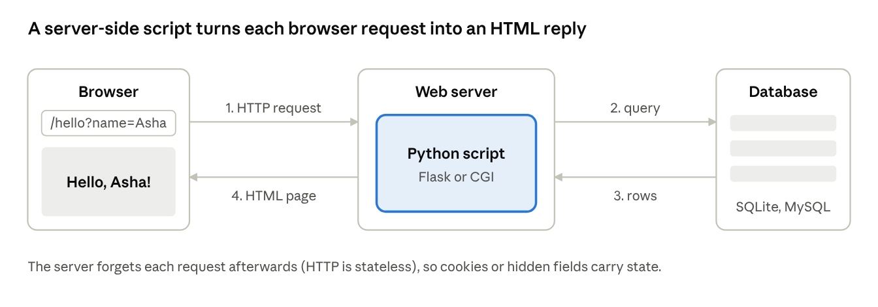
web request cycle · 4 steps

2.5 The PyMailCGI server
PyMailCGI is the web version of the same mail tool, also a case study in Programming Python. Instead of a desktop window, the user works in a browser, and Python scripts on the web server do the work.
- The browser shows HTML forms and sends each click or submit to the server as an HTTP request.
- The server-side Python scripts read the form data, connect to the mail server with poplib and smtplib, and generate HTML pages as replies.
- Because HTTP is stateless, the scripts must pass the user's session information from page to page (through URLs or hidden form fields) and treat passwords with care.
- Nothing needs installing on the user's computer, which is the main advantage over PyMailGUI; the trade-off is a less responsive interface, because every action is a round trip to the server.
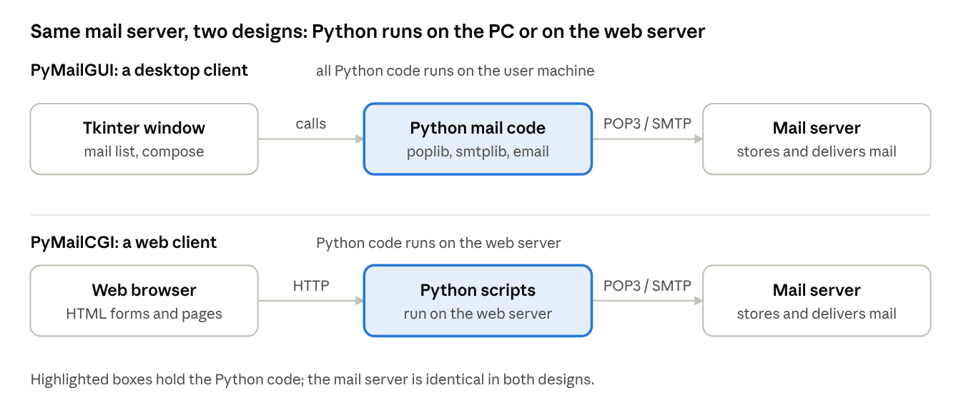
PyMailGUI versus PyMailCGI · 2 designs

3. Tools and Techniques
Real programs need to save data between runs, organise it efficiently, process text and sometimes reuse fast C code; this section covers the four tool areas in the syllabus.

3.1 Databases and persistence
Persistence means keeping data after the program ends. Python offers a ladder of options, from saving one object to running a full database.
Tool | What it stores | Best for
open() text files | Plain text, CSV | Simple logs and tables
json | Lists, dictionaries, numbers, strings as text | Settings and data shared with other languages and web APIs
pickle | Almost any Python object as bytes | Saving your own objects quickly (load only trusted files)
shelve | A dictionary of pickled objects on disk | A simple key-value store
dbm | Byte keys to byte values | Very small key-value files
sqlite3 | Tables queried with SQL, inside one file | Structured data and anything needing queries
ORM (SQLAlchemy) | Tables presented as Python classes | Larger applications on MySQL, PostgreSQL and others
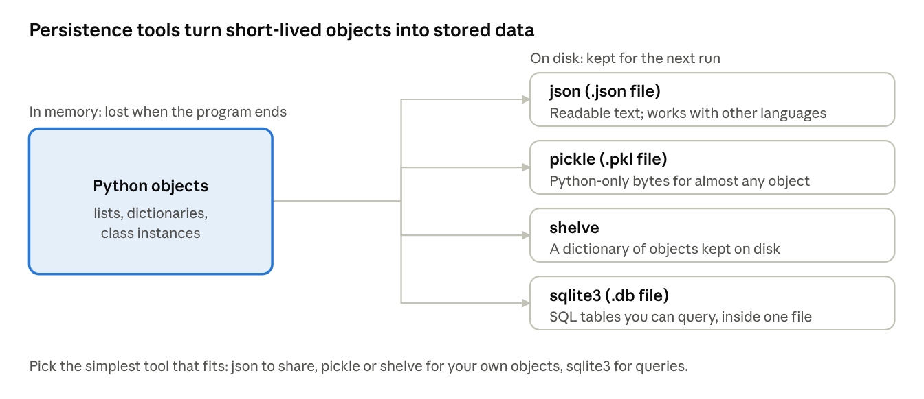
persistence tools · 4 options
import pickle, shelve, json
student = {"name": "Asha", "marks": [72, 85, 91]}
with open("student.pkl", "wb") as f:
pickle.dump(student, f) # save the object
with open("student.pkl", "rb") as f:
print(pickle.load(f)) # load it back
with shelve.open("school") as db: # behaves like a dictionary stored on disk
db["asha"] = student
print(db["asha"]["marks"])
print(json.dumps(student)) # '{"name": "Asha", "marks": [72, 85, 91]}'
Never unpickle data from an untrusted source: loading a crafted pickle can run arbitrary code.
SQLite is a complete SQL database in the standard library; the same SQL works with other database systems through their drivers, which follow the same DB-API pattern of connect, cursor, execute and commit.
import sqlite3
conn = sqlite3.connect("school.db") # creates the file if missing
cur = conn.cursor()
cur.execute("CREATE TABLE IF NOT EXISTS students (id INTEGER PRIMARY KEY, name TEXT, marks INTEGER)")
cur.execute("INSERT INTO students (name, marks) VALUES (?, ?)", ("Asha", 85)) # ? placeholders prevent SQL injection
conn.commit() # make the change permanent
for row in cur.execute("SELECT name, marks FROM students WHERE marks > ?", (60,)):
print(row) # ('Asha', 85)
conn.close()

3.2 Data structures
A data structure organises data so that the operations you need are fast. Python's built-in list, tuple, dictionary and set cover most needs; the standard library and your own classes supply the rest.
Structure | Python tool | Operations | Typical use
Stack (last in, first out) | list with append() and pop() | push, pop | Undo, expression evaluation, backtracking
Queue (first in, first out) | collections.deque | append(), popleft() | Task scheduling, breadth-first search
Priority queue | heapq | heappush(), heappop() | Always take the smallest item first
Linked list | Your own Node class | insert and delete without shifting | Learning pointers; rarely needed in Python
Tree | Your own Node class with children | traverse, search | File systems, decision trees, parsing
Hash table | dict and set | lookup, insert, delete in near-constant time | Counting, caching, removing duplicates
Graph | A dictionary of lists | traverse, shortest path | Networks and maps
from collections import deque
import heapq
stack = []
stack.append(1); stack.append(2)
print(stack.pop()) # 2 (last in, first out)
queue = deque(["a", "b"])
queue.append("c")
print(queue.popleft()) # 'a' (first in, first out)
heap = []
for n in [5, 1, 3]:
heapq.heappush(heap, n)
print(heapq.heappop(heap)) # 1 (smallest first)
class Node: # building block for linked lists and trees
def __init__(self, value):
self.value = value
self.left = None
self.right = None
def inorder(node): # binary tree traversal using recursion
if node:
yield from inorder(node.left)
yield node.value
yield from inorder(node.right)
root = Node(2); root.left = Node(1); root.right = Node(3)
print(list(inorder(root))) # [1, 2, 3]
↗ stack, queue, linked list and tree · 4 pictures

3.3 Text and language
Text processing is central to data work: cleaning strings, searching with patterns and reading structured formats.
- String methods: split, join, strip, replace, find, startswith handle most day-to-day jobs.
- Regular expressions (re): a compact pattern language for searching and replacing text.
- Structured text: json, csv, xml.etree.ElementTree and html.parser read common data formats.
- Unicode: Python 3 strings hold Unicode text; use encode("utf-8") and decode("utf-8") at the boundary with files and networks.
- Command-line languages: argparse reads options such as --input data.csv.
- Parsing a language: to process your own mini-language you tokenise the text (split it into words and symbols) and then parse the tokens by rules. Python can also run text as code with eval() and exec(), but never do that with untrusted input.
import re, json
text = "Contact: asha@example.com, ravi@test.org on 2026-10-09"
print(re.findall(r"[\w.]+@[\w.]+\.\w+", text)) # ['asha@example.com', 'ravi@test.org']
print(re.search(r"(\d{4})-(\d{2})-(\d{2})", text).groups()) # ('2026', '10', '09')
print(re.sub(r"\d", "#", "Room 204")) # 'Room ###'
raw = '{"city": "Kochi", "temp": 31}'
data = json.loads(raw) # text -> dictionary
print(data["city"])
def tokenize(expr): # a tiny tokenizer
return re.findall(r"\d+|[+\-*/()]", expr)
print(tokenize("12 + 3*(4 - 1)")) # ['12', '+', '3', '*', '(', '4', '-', '1', ')']

3.4 Python/C integration
Python is easy to write but slower than C for heavy number crunching, and a huge amount of useful software already exists as C libraries. Integration lets the two work together in one of two directions.
- Extending: call C code from Python. You write a C extension module, or use a bridge, and then simply import it. NumPy, pandas and many other libraries work this way.
- Embedding: call Python from C. A C program starts the Python interpreter inside itself so users can script the application.
Approach | How it works | Effort
ctypes | Load a compiled shared library and call its functions from pure Python | Low
cffi | Describe the C functions in C-like declarations and call them | Low to medium
Cython | Write Python-like code with C types; it compiles to a C extension | Medium
C extension module (Python.h) | Write C functions that follow the Python C API | High, but fastest and most flexible
subprocess | Run a separate C program and read its output | Low, but slower
↗ extending and embedding · 2 lanes
# ctypes: call the C maths library from Python (Linux or macOS)
import ctypes
from ctypes.util import find_library
libm = ctypes.CDLL(find_library("m"))
libm.cos.argtypes = [ctypes.c_double] # declare the C types
libm.cos.restype = ctypes.c_double
print(libm.cos(0.0)) # 1.0

/* fastmath.c : a minimal C extension module */
#include <Python.h>
static PyObject* add(PyObject* self, PyObject* args) {
int a, b;
if (!PyArg_ParseTuple(args, "ii", &a, &b)) return NULL; /* read 2 ints */
return PyLong_FromLong(a + b); /* return a Python int */
}
static PyMethodDef Methods[] = {
{"add", add, METH_VARARGS, "Add two integers"},
{NULL, NULL, 0, NULL}
};
static struct PyModuleDef mod = {PyModuleDef_HEAD_INIT, "fastmath", NULL, -1, Methods};
PyMODINIT_FUNC PyInit_fastmath(void) { return PyModule_Create(&mod); }
After building the module (for example with setuptools), Python code simply runs import fastmath and then fastmath.add(2, 3), which returns 5.

Quick revision
Remember one core idea for each topic.
- GUI options: Tkinter ships with Python; PyQt, wxPython and Kivy are installed separately.
- Widgets and layout: create widgets inside a parent, place them with pack, grid or place (one manager per container).
- Event loop: mainloop() waits for events and runs your callbacks; keep callbacks short.
- Coding techniques: classes, bind(), control variables, after() timers and worker threads with a queue.
- Customizing: options such as font, bg and relief, ttk themed widgets, images and subclassed widgets.
- Network scripting: sockets carry bytes; a server does bind, listen, accept; a client does connect, send, receive.
- Client-side versus server-side: client-side runs on the user's machine and requests services; server-side runs on the server in answer to requests.
- PyMailGUI: a Tkinter mail client that combines GUI, poplib, smtplib, email and threads.
- PyMailCGI: a browser-based mail client where server-side scripts do the work and state is passed between pages because HTTP is stateless.
- Persistence: json for portable data, pickle and shelve for Python objects, sqlite3 for SQL.
- Data structures: list as stack, deque as queue, heapq as priority queue, dict and set as hash tables, classes for trees and linked lists.
- Text and language: string methods, re patterns, json and csv parsing, tokenise then parse.
- Python/C integration: extending calls C from Python (ctypes, Cython, C extension modules); embedding runs Python inside a C program.

Likely exam questions
Short answer (2 to 3 marks)
- Name any four Tkinter widgets and state the use of each.
- Differentiate between pack, grid and place.
- What is a callback function in a GUI program?
- What is a socket? Which module provides it in Python?
- Differentiate between client-side and server-side scripting.
- What is the difference between pickle and json?
- What is the difference between extending and embedding Python?
Long answer (5 to 10 marks)
- Explain the structure of a Tkinter program with a suitable example, covering widgets, layout and the event loop.
- Explain how GUI widgets can be customised, with examples.
- Describe how a TCP client and server communicate using sockets, with a program.
- Explain the working of PyMailGUI and PyMailCGI and compare the two designs.
- Explain the options for persistence of data in Python, with examples of pickle, shelve and sqlite3.
- Describe stack, queue and tree implementations in Python.
- Explain the ways of integrating Python with C code.

References

Text books
- Mark Lutz, Learning Python, O'Reilly.
- Mark Lutz, Programming Python, O'Reilly (GUI programming, Internet programming, PyMailGUI, PyMailCGI, databases and persistence, data structures, text and language, and Python/C integration).
- Wes McKinney, Python for Data Analysis, O'Reilly.

Reference books
- Martin C. Brown, Python: The Complete Reference, McGraw Hill Education.
- Paul Barry, Head First Python, O'Reilly.

